**Actors:** Manager, member, trainer, dietician.

**Noun Extraction:**

1. **Managers:** Membership packages, salons, sessions, vitamin bar products, sms communication system.
2. **Members:** Membership registration, package purchase, wristband, nutrition program, training program, sms notifications.
3. **Trainer:** Training program, health and sports information.
4. **Dietician:** Diet program, health and sports information, body information.

**USE CASES**

**General Use Case**

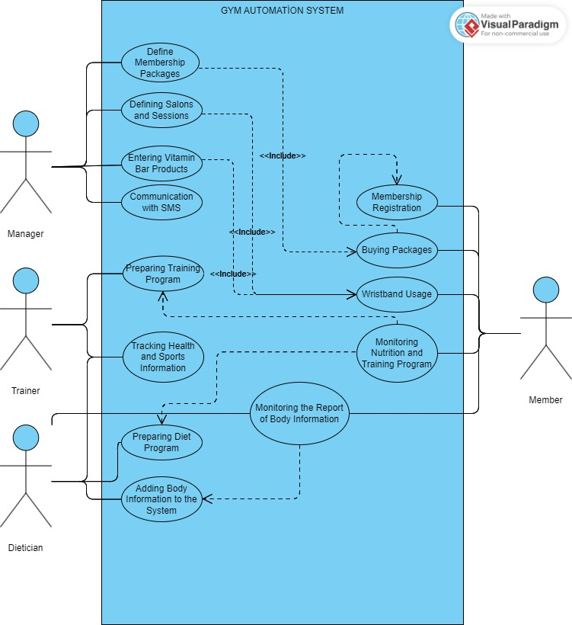

1. **Define Membership Packages Use Case**

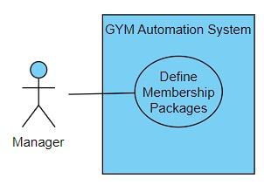

**Brief Description:** Managers define the different membership packages offered at the gym. These packages include various features such as gym access, number of sessions, vitamin bar products, etc.

1. **Define Salon and Session Use Case**

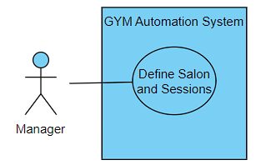

**Brief Description:** Managers define the different sections of the gym and the sessions that will take place in these sections.

1. **Enter Vitamin Bar Product Use Case**

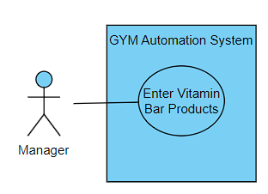

**Brief Description:** Administrators enter the products to be sold in the vitamin bar. These products can be purchased with money loaded on members' wristbands.

1. **Communicating with SMS Use Case**

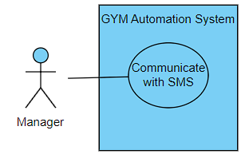

**Brief Description:** Administrators communicate with members via SMS.This includes things like sending an automatic SMS 1 week before their membership date expires.

1. **Membership Registration Use Case**

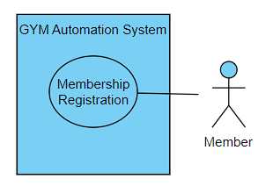

**Brief Description:** Members can become a member of the gym.During the membership process, members choose a membership package, which is loaded onto their card integrated into the wristband.

1. **Buying Packages Use Case**

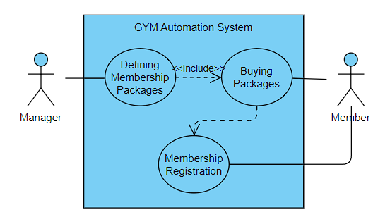

**Brief Description:** Members can purchase one of several membership packages offered at the gym.

1. **Wristband Usage Use Case**

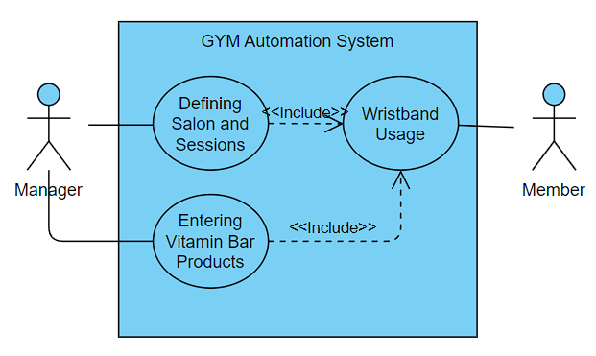

**Brief Description:** Members use their wristbands for lounge access, locker use and shopping at the vitamin bar. Wristbands only give access to the lounges related to the package purchased by the member.

1. **Monitoring Nutrition and Training Program Use Case**

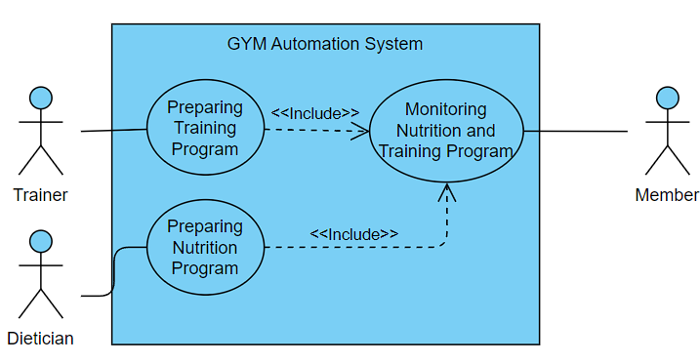

**Brief Description:** Members can view the nutrition and training programs prepared for them by dieticians and trainers.

1. **Preparing Training Program Use Case**

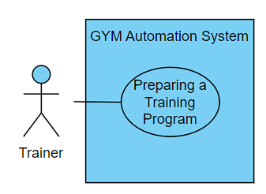

**Brief Description:** Trainers define special training programs for members. These programs are uploaded to the system so that members can view them on the mobile application.

1. **Tracking Health and Sports Information Use Case**

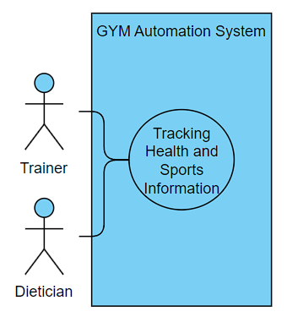

**Brief Description:** Trainers and dietitians keep track of members' health and sports information. This information is used to monitor members' training programs, diet programs and overall progress.

1. **Preparing Diet Program Use Case**

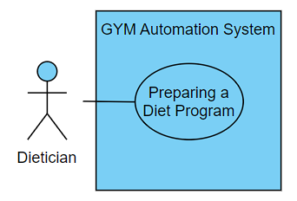

**Brief Description:** Dietitians prepare special diet programs for members. These programs are uploaded to the system for members to view.

1. **Adding Body Information to the System Use Case**

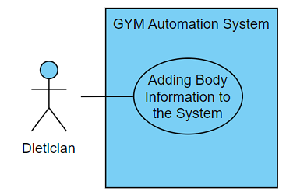

**Brief Description:** Dietitians periodically transfer members' body muscle, fat, water, etc. information to the system. This information is used to monitor members' diet programs and their overall progress.

1. **Monitoring Report of Body Information Use Case**

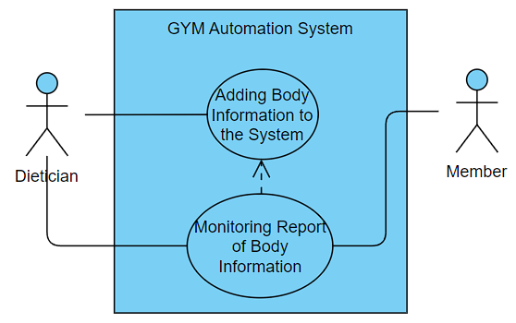

**Brief Description:** The dietician can add body information to the system and then monitor. The member can monitor their body information.